1. **Difference between Browser JS(console) v Nodejs**

| S.No | Javascript | NodeJS |
| --- | --- | --- |
| 1. | Javascript is a programming language that is used for writing scripts on the website. | NodeJS is a Javascript runtime environment. |
| 2. | Javascript can only be run in the browsers. | We can run Javascript outside the browser with the help of NodeJS. |
| 3. | It is basically used on the client-side. | It is mostly used on the server-side. |
| 4. | Javascript is capable enough to add HTML and play with the DOM. | Nodejs does not have capability to add HTML tags. |
| 5. | Javascript can run in any browser engine as like JS core in safari and Spidermonkey in Firefox. | V8 is the Javascript engine inside of node.js that parses and runs Javascript. |
| 6. | Javascript is used in frontend development. | Nodejs is used in server-side development. |
| 7. | Some of the javascript frameworks are RamdaJS, TypedJS, etc. | Some of the Nodejs modules are Lodash, express etc. These modules are to be imported from npm. |

1. **Rendering**
2. Rendering in browser follows below process

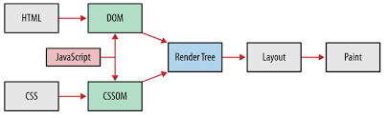

1. Our Javascript code will be involved in both DOM and CSSOM
2. In render tree tags like head, script,title.. will not appear.
3. Layout will style the content which is going to be displayed on browser, immediate layout will do font/browser resize, etc.
4. Painting setup will take layedout render trees and create layers. Paint process involves producting bitmap from each layer and uploading it to GPU as a texture and composites it as a final image which will be rendered to the browser.
5. **Code Output**

typeof(1) - number

typeof(1.1) - number

typeof(‘1.1’) - string

typeof(true) - boolean

typeof(null) - object

typeof(undefined) - undefined

typeof([]) - object

typeof({}) - object

typeof(NaN) - number